

**Assignment-2**

**Course name:** Distributed Systems: principles and Development(Term-3-2017)

**Course code:** COIT20257

**Lecturer:** Ahmed El-Hadad

**Tutor:** Ahmed El-Hadad

**Due Date:** Friday of week-10 (26/1/2018)

**Prepared By: -**

**Group No: -1**

**Name:** Ramjiyani, Prajalkumar Natvarlal

**Student Id:** 12045947

**Name:** Jay Atulbhai Mehta

**Student Id:** 12045043

Table of Contents

1. Introduction 3

2. Target Audience 4

3. Installation and execution steps 5

4. References 12

# Introduction

Purpose of this document is to guide how to use this software and what sort of functinality is available.

Basically, this software is designed as console application with following basic functinalty:

* Calculate PI
* Calculate Primer numbers
* Calculate Greatest Common Divisor

# Target Audience

This document is designed for end user help so that they can understand the software well and use it properly.

# Installation and execution steps

First step is compile all java files

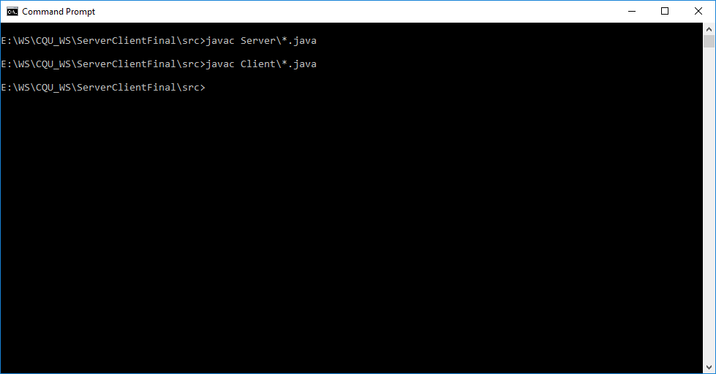

Run the server first and then start Client

Starting Server

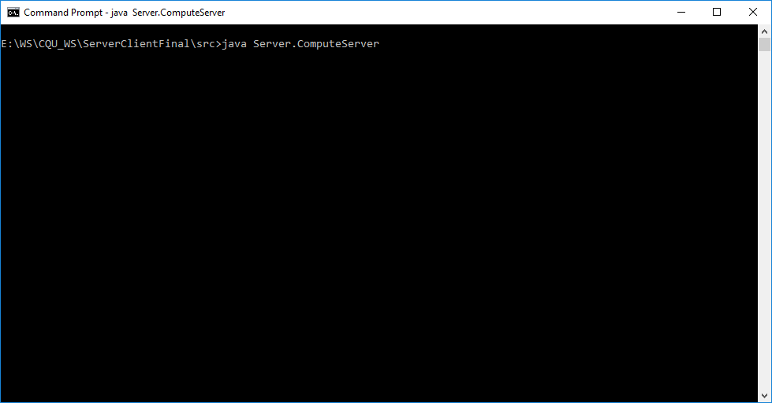

Starting Client

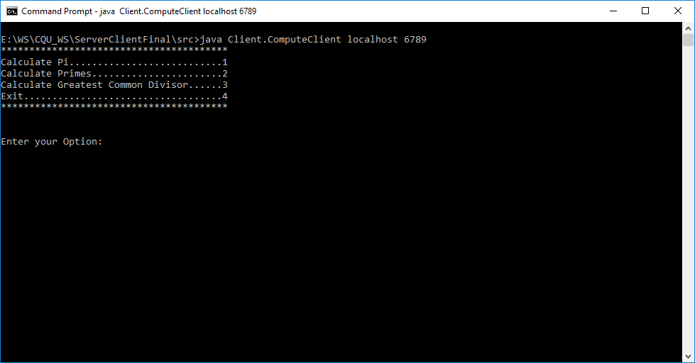

Try to run the Calculate PI before uploading the class file to repository, so it will show below error message.

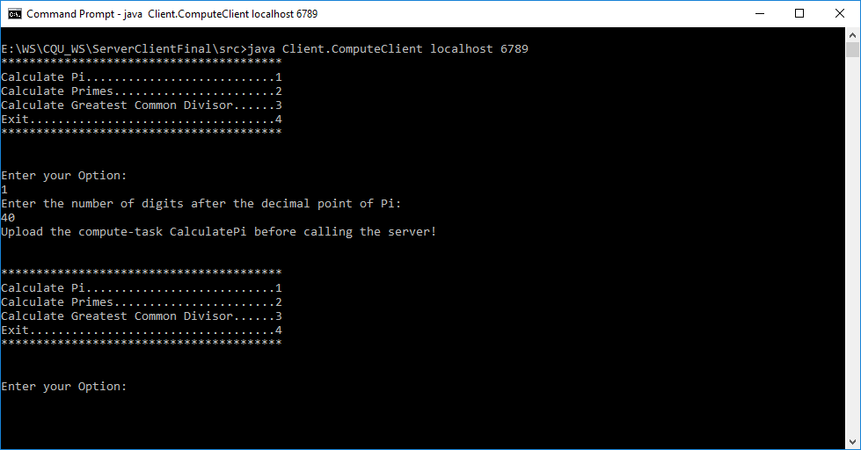

Uploading all classes to the server repository

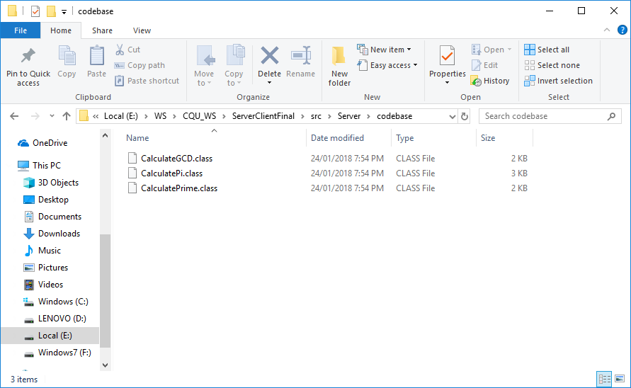

Again, testing Calculate PI after uploading class file to repository:

Client-side Screen

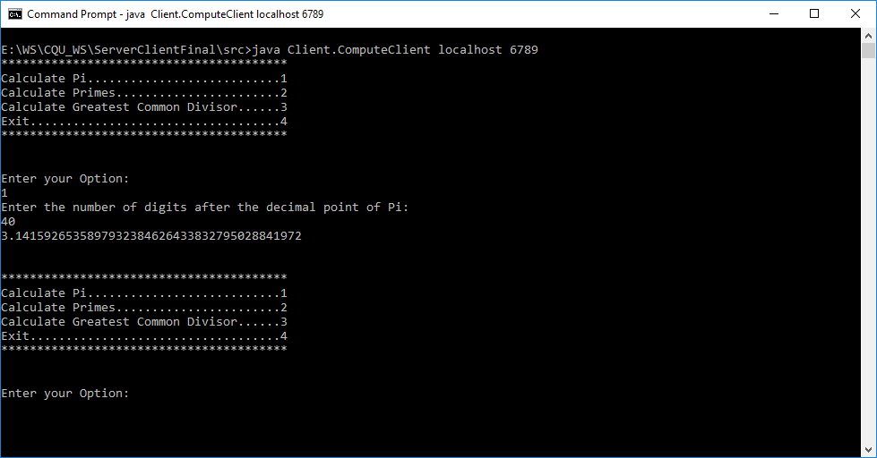

Server-side Screen

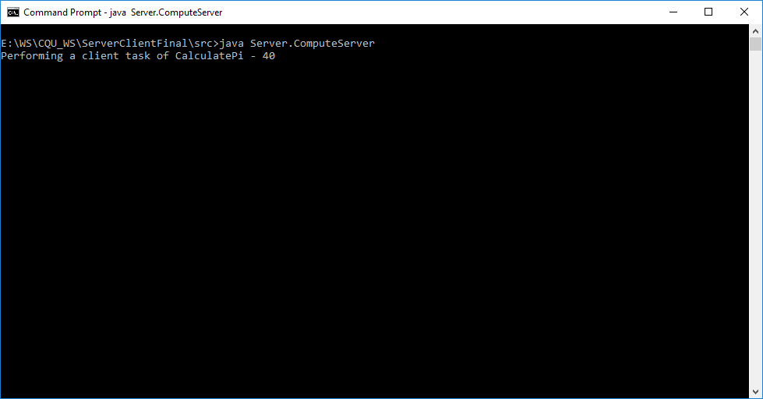

Testing Calculate Primes functionality

Client-side Screen

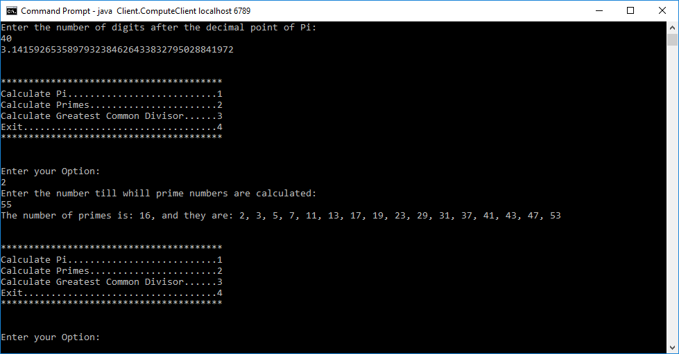

Server-side Screen

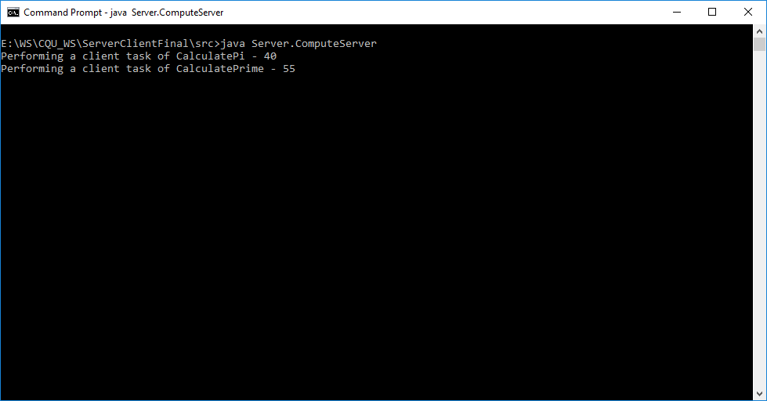

Testing Calculating GCD

Client-side screen

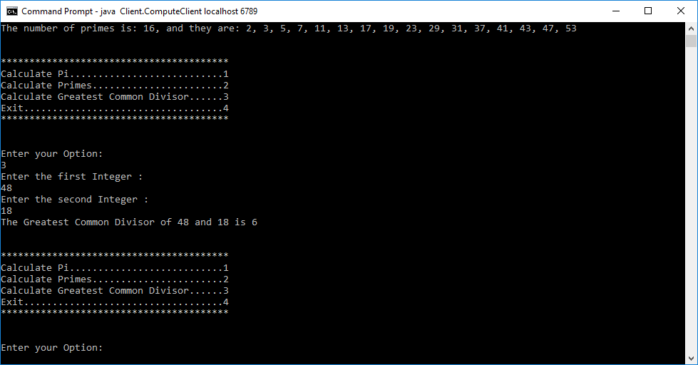

Server-side screen

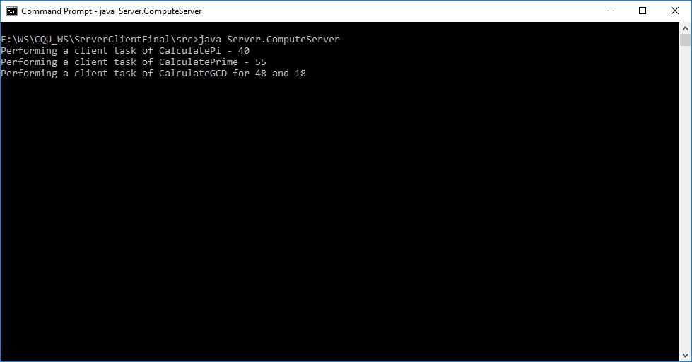

Testing Exit functionality

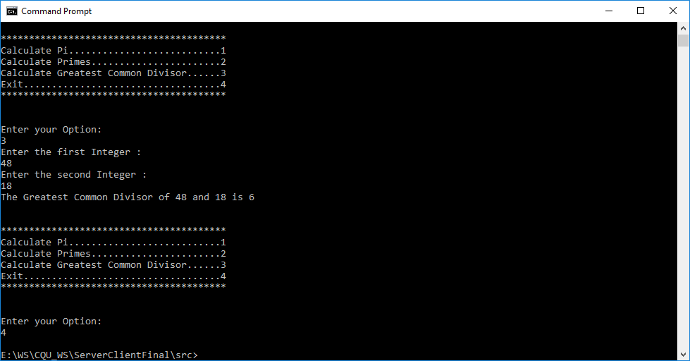

Testing validation for invalid input

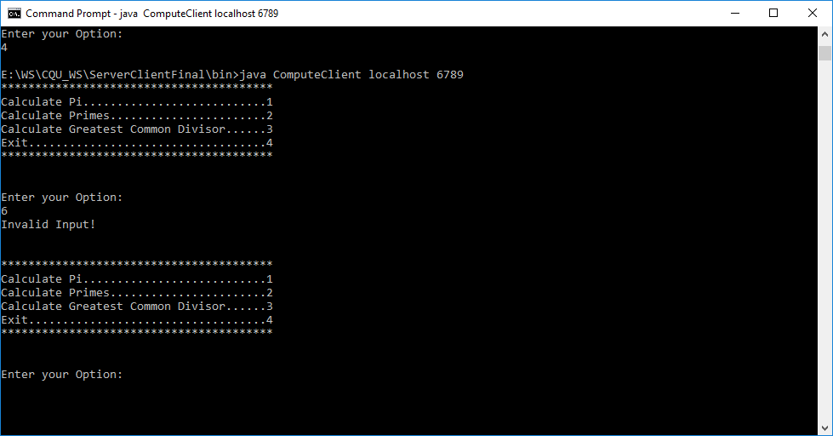

Notes: We have developed this console application using Eclipse software which is similar to NetBeans Software.

# References

Anon, ‘User Guide Tutorial’, *Klariti.com*, viewed 26 January 2018, http://www.klariti.com/technical-writing/User-Guides-Tutorial.shtml